**Circuit:**

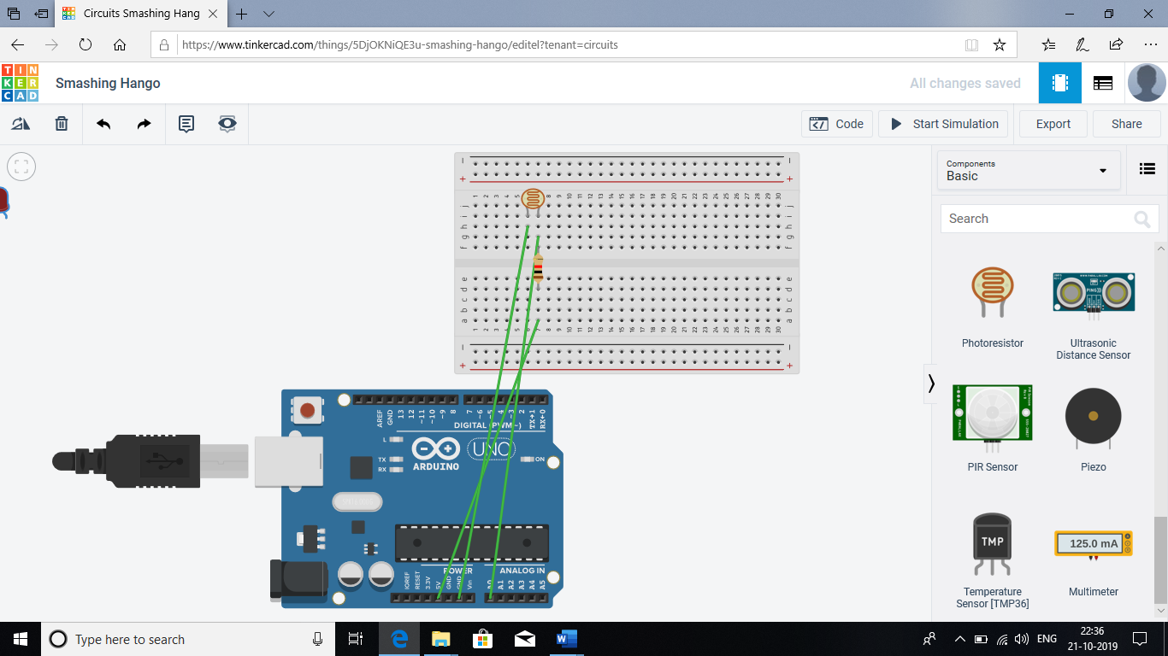

**Theory :-**

**LEDs** are a particular type of diode that convert electrical energy into light. In fact, LED stands for “Light Emitting Diode.” And this is reflected in the similarity between the diode and LED schematic symbols.

In short, LEDs are like tiny lightbulbs. However, LEDs require a lot less power to light up by comparison. They’re also more energy efficient, so they don’t tend to get hot like conventional light bulbs do (unless you’re really pumping power into them). This makes them ideal for mobile devices and other low-power applications. Don’t count them out of the high-power game, though. High-intensity LEDs have found their way into accent lighting, spotlights and even automotive headlights.

The brightness of an LED is directly dependent on how much current it draws. That means two things. The first being that super bright LEDs drain batteries more quickly, because the extra brightness comes from the extra power being used. The second is that you can control the brightness of an LED by controlling the amount of current through it. But, setting the mood isn’t the only reason to cut back your current.

The **Arduino Uno** is an open-source microcontroller board. The board is equipped with sets of digital and analog input/output (I/O) pins that may be interfaced to various expansion boards (shields) and other circuits. The board has 14 Digital pins, 6 Analog pins, and programmable with the Arduino IDE (Integrated Development Environment) via a type B USB cable. It can be powered by the USB cable or by an external 9-volt battery, though it accepts voltages between 7 and 20 volts.

**Concept Used :** -

A circuit is made in which 2 digital pins are used where a pin (lets say 7) is connected to a LED which is further connected to ground. Now another pin   
(lets say 12) is connected to switch. One end of the switch is connected to 5V supply and intersection of pin 12 and switch is connected to resistor which is connected to ground from another end. Value of resistance is very high. The resistors are used to resist the flow of current. Coding is done in such a way that when switch is pressed led turns on and again when switch is pressed led turns off.

**Learning and Observations : -**

* Making circuits using Arduino.
* Connecting LED and switch with arduino.
* Ground has least resistance.
* Working of Arduino UNO.
* Coding to be done on Arduino.exe for stimulation of the experiment.

**Problems & Troubleshooting: –**

No problem occurred during the execution of the experiment.

**Precautions :–**

1. The circuit made can be wrong.
2. Any Element used may be defective.
3. The coding done can be incorrect due to which stimulation can be failed.
4. Port Selection for Arduino can be incorrect due to which it won’t upload on Arduino Board and resulting in failure of experiment.